SOCOTEC BUSINESS CONTINUITY POLICY

SOCOTEC UK’s Business Continuity Management policy (BCM) is aimed at ensuring that the SOCOTEC UK Group can maintain or return to business as usual after a disruption, major incident or crises.
The Group makes every effort to ensure that it is protected against any risks or threats that could have a material impact upon disrupt or interrupt its operations and is supported by the CEO and main board.

Our priority is wherever possible to eliminate or mitigate business risk.

The BCM policy is supported by a BCM system, which has representation from all of the key areas of the business.

- Facilities
- Finance
- Information Technology
- Health and Safety
- Quality and Environment
- Human Resources
- Operations

The BCM system has been developed following key principles, which are to:

- Identify, and address risks which may jeopardise operations, key business
processes, financial and reputation position or legal standing;
- Minimise the effects of disruption to the business;
- Ensure the safety and welfare of employees;
- Ensure business is resumed as soon as possible;
- Promote business continuity planning and preparedness;
- Communicate to all staff;
- Rehearse and test our approach to possible risks;
- Deliver its critical activities at an acceptable pre-defined level.

SOCOTEC UK is committed to the principle of continual improvement and has developed a BCM system against the requirements and guidance of societal security - Business continuity management systems –
Requirements BS ISO 22301:2012 and Guidance BS ISO 22313:2012.

SOCOTEC UK’s BCM procedures and information are maintained on the SOCOTEC Intranet in readiness for use and is available 24/7 if required.

Signed
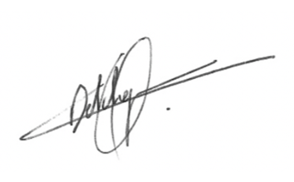
Nicolas Detchepare
Chief Executive Officer
Date: 18th January 2023

